**1.0 - Source Code Based Testing:**

**1.1 - Control Flow Based Testing:**

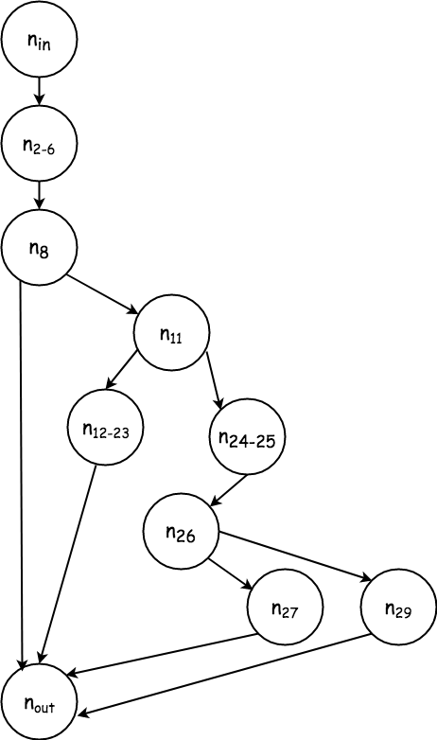

*Exhibit 1: Control Flow Diagram*

Only C2 path coverage is needed, since it subsumes all other control flow methods, and is attainable in this case with only 4 tests, which were already derived during specification based testing.

**1.1.1 Test Cases**

**LOOP COVERAGE**

|  |  |  |  |  |  |
| --- | --- | --- | --- | --- | --- |
| **ID** |  | **PARAMETERS** |  | **Coverage** | |
| word_id | word | value | path | **%** |
| T_0_0 | “tenbergen” | “00-14-22-01-23-45” | “gold” | In, 2-6, 8, out | 1/4 = 25% |
| T_0_1 | “tenbergenn” | “00-14-22-01-23-45” | “green” | In, 2-6, 8, 11, 12-23, out | 2/4 = 50% |
| T_0_2 | null | “00-14-22-01-23-45” | “GREEN” | In, 2-6, 8, 11, 24-25, 26, 27, out | 3/4 = 75% |
| T_0_3 | “tenbergen” | null | “GreeN” | In, 2-6, 8, 11, 24-25, 26, 29, out | 4/4 = 100% |

**1.2 - Data Flow Based Testing**

**Skipped since path coverage subsumes all-use criteria**